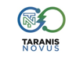

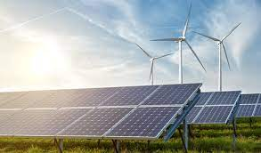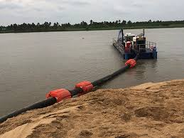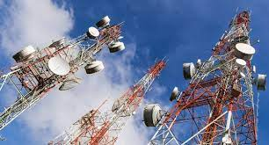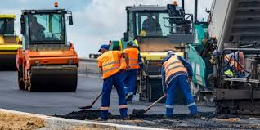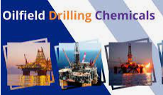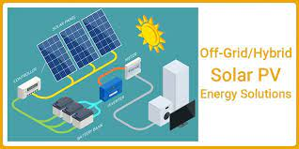

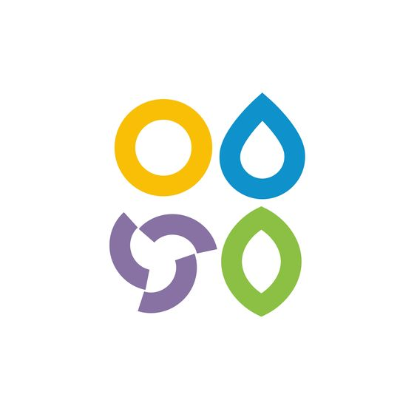

CORPORATE BROCHURE

www.taranisnovus.com

Table of Contents

[Brief History of TNL 3](#_Toc138768852)

[Our Mission 5](#_Toc138768853)

[Our Vision 5](#_Toc138768854)

[tARANIS NOVUS LIMITED (tnl) & INFRASTRUCTURE Expertise 7](#_Toc138768857)

[Health and Safety 9](about:blank#_Toc138768860)

[Social Responsibility 10](#_Toc138768861)

[Quality 10](#_Toc138768863)

[Solar Park Construction 13](#_Toc138768866)

[BENEFITS OF CHOOSING TNL FOR BUILDING ENERGY AND INFRASTRUCTURE PROJECTS. 15](#_Toc138768867)

[TNL Model template for the Design and Construction of Energy / INTEGRATED Industrial Parks 16](#_Toc138768868)

[PICTORIAL IMPRESSION OF THE PROPOSED ENERGY / INTEGRATED INDUSTRIAL PARKS 17](#_Toc138768869)

[TNL DEVELOPMENT TEAM 18](#_Toc138768870)

[CONTACT INFO: 25](#_Toc138768871)

[Disclaimer 25](#_Toc138768872)

****

Taranis Novus Limited (TNL) is a leading global energy, engineering, agro-industrial, automotive, technological and innovation business founded in Nigeria.

The company has global and strong presence in Nigeria, South Africa and partnerships in Asia, Europe and North America with its cream of experienced and dedicated professionals cutting across finance, banking, oil and gas, information technology, engineering and agriculture.

www.taranisnovus.com

# Brief History of TNL

**Taranis Novus Limited (TNL)** was incorporated in 2023 in Nigeria as a corporate company. TNL apart from its strong representation in Nigeria plans to spread its business scope to the rest of Africa. TNL’s objective is anchored in its partnership quest to for the best technology partners is primarily based on its collective desire to be Nigeria’s and Africa’s choice of Renewable Energy and Development Construction solutions provider.

The scope of the service being offered by TNL includes the following:



* **Renewable Energy:** Solar, Wind and Hydro Electric Power
* **Waste to Energy (WTE)** – Thermal & Biological Combustion types
* **Construction:** Civil, Structural, Mechanical and Electrical Engineering
* **Oil and Gas:** Upstream, Downstream, Marine Services, Supplies & Procurement
* **Information & Communications Technology** services
* **Mining:** Solid Minerals
* **Professional Training & Consultancy.**

**OTHER SERVICE OFFERINGS**

* **Solar-based Inverter & Energy Storage** Power Solution for Residential, Commercial and Industrial Clients.
* **Sales** and replacement of Alkaline-based batteries with Lithium Iron phosphate batteries due to the longer life span, no maintenance, extremely safe, lightweight, improved discharge and charge efficiency. LiFePO4 batteries are not the cheapest in the market, but due to a long-life span and zero maintenance, it's the best investment you can make over time.
* **Sales and Service of Electric Vehicles**, Buses, Tricycles and Electric Farm vehicles, Electric Golf carts etc.

**Taranis Novus Limited (TNL)** is a global energy project development firm that specializes in all aspects of **launching, facilitating, and completing commercial and utility-scale solar, thermal, wind and waste to energy projects worldwide**. With significant industry experience in **stewarding large-scale energy development and infrastructure projects** from initial discussions with government bodies, suppliers, and production resources all the way through plant startup. TNL has the focus, expertise, and relationships to manage energy development and infrastructure projects of all sizes and magnitudes.

TNL’s primary emphasis entails facilitating large-scale **energy development and infrastructure projects from initiation of preliminary discussions with government bodies, suppliers and production resources, all the way through plant startup and commercial operation**.

TNL executives have long-standing track records of **developing solar energy and thermal energy plants, stations, parks, and facilities in Africa.**  Our commitment to bringing electricity to those in need has helped us gain much-valued respect with governments and their respective leaders and citizens.

TNL is committed to achieve a reputation for Quality and Excellence in the domestic and international renewable energy sector while focused on bringing stable energy to under-served populations. We fully understand the logistical intricacies involved in developing energy. Although our years of experience in managing large-scale development projects is certainly important, we firmly believe that our focus on building **relationships with government decision makers, regulatory bodies, raw materials suppliers, technology vendors, engineering firms, and downstream labor forces** sets us apart from our competitors.

The world consumes more energy than ever before. Our increasingly urban lifestyle has led to an increase in the consumption of energy for illumination, transportation, industrial processes, entertainment, computer use, and production. Energy poses one of the biggest limits for our development, and the decrease of global crude reserves has turned the pressure on for finding new and better ways to power our lives with a minimal environmental effect. As a species, we have to find the energy sources that will power our growth for generations to come while minimizing our impact on our natural resources.

Technologies to maximize the efficiency of Photovoltaic Solar, CSP, Thermal, Wind, Waste-to-Energy, Nuclear, Hydrogen, Tidal, and Geothermal sources are all part of the solution. However, large scale implementation of these technologies does require major capital investment and are expensive to maintain. Countries, Financial Institutions, Entrepreneurs, and Citizens around the world are taking exciting steps to develop some promising solutions to our energy needs. However, the most promising technologies are still in research phase, and their implementation will require time.

At **TNL** we ask ourselves the question: **How can we produce the Best Clean Energy, using resources available here and today?**

**Global Expertise**

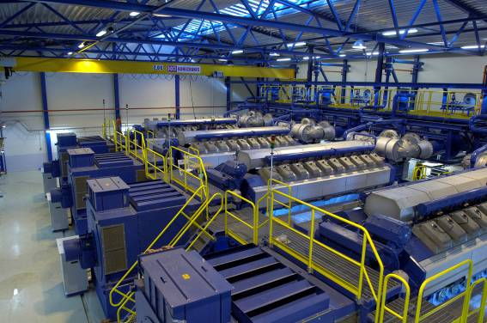

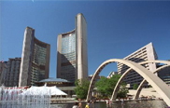

TNL team members have appreciable energy development experience and exposure to infrastructure projects.

# Our Mission

**Our Mission is to contribute to the general wellbeing of African people through a cleaner and more affordable living conditions. TNL** is always committed to furthering our reputation for Quality & Excellence in the domestic and international renewable energy sector. We encourage social awareness and environmental responsibility during our projects’ execution and concern for safety is forever paramount. The strength of **TNL** is its commitment to excel in all areas; its dedicated, experienced, and hardworking staff; and its ability to live up to the satisfaction of its clients.

# Our Vision

**Our vision is to be the leading energy technology provider and consultant of choice in Africa.** The vision fuels our ambition to be a leading energy technology provider and consultant of choice in line with the UN Sustainable Development Goals (SDGs). We continuously harp on our holistic approach to creating value for our clients, employees, society and shareholders by considering social, environmental and economic risks and opportunities in our business processes and strategies.

The global challenge is to continue developing society and create growth with a limited adverse impact on the environment and society. Engaging with and even encroaching upon nature is inevitable when meeting the growing needs for infrastructure, housing, energy production, transportation, goods and services to mention a few. We are very confident that our holistic, technical and scientific capabilities are needed to advise our clients on decisions and add solution values that empower our clients and society to develop in a more sustainable and balanced way.

The UN’s SDG’s agenda for sustainable development, which identifies a set of 17 universal Sustainable Development Goals (SDGs), is an action plan to combat these global challenges, which includes targets and indicators. TNL is well-positioned to support both the public and private sectors as they work towards achieving these goals. The SDGs will be an opportunity and priority for TNL going forward, as they emphasize the

need for our technical and integrated solutions to global challenges.

We continue our focus on conducting business in a responsible way. This is not only to ensure that our employees are aware of our targets and progress, but also to ensure that responsible behavior becomes embedded throughout the organization, leading to uniform high performance.

**UN SDG’s - United Nations Sustainable Development Goals**

TNL takes an active role in developing the global community we are part of through the solutions we provide. The UN SDGs will be included as a framework for developing specific targets and actions for TNL’s corporate responsibility effort to ensure that these become integrated into our business.

The figure below highlights the SDGs considered most relevant to TNL in relation to our areas of expertise.







# tARANIS NOVUS LIMITED (tnl) & INFRASTRUCTURE Expertise

TNL executives have long-standing track records of developing solar energy and thermal energy plants, stations, parks, and facilities and our commitment to bringing electricity to those in need has helped us gain much-valued respect with governments, their leaders, and their citizens.

**Comprehensive Energy Development & Infrastructure Services**

As a full-service energy development and infrastructure projects firm, TNL skilled project developers and project managers are committed to meeting the needs of government clients and their citizens and place great value on safety, quality and sound project management. TNL works with all project stakeholders to **ensure the successful completion of large-scale energy production initiatives**. After engineering, procurement and planning processes are complete, TNL construction teams and its partners will handle all aspects of the build-out for our clients’ solar and/or thermal energy parks.

TNL in conjunction with its partners provide clients with:

* **Plant commissioning and Overall oversight of plant operations**
* **Plant recruiting and staffing services**
* **Staff training (for all levels of plant operations personnel)**
* **Continuous monitoring and testing**
* **Operation and Maintenance**

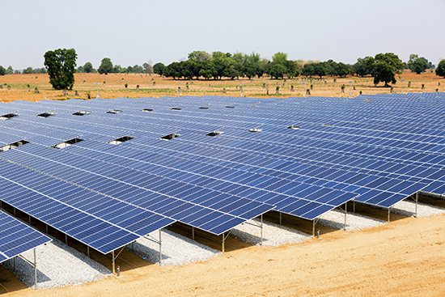 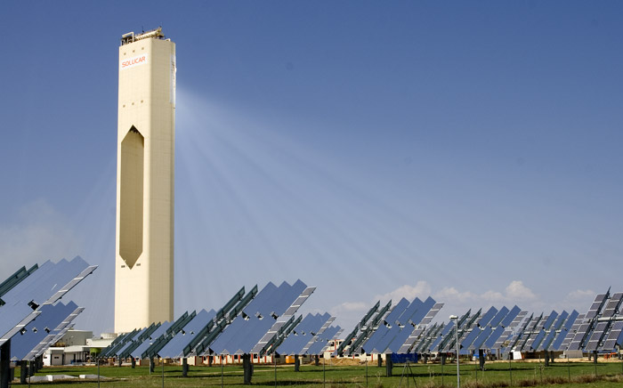 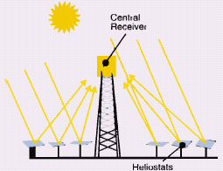 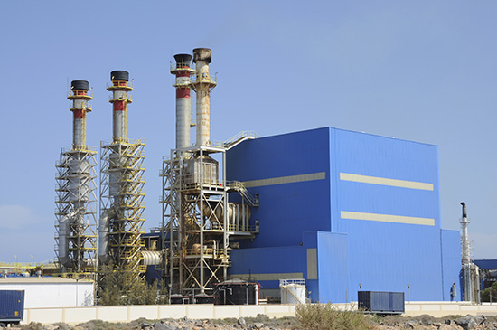

# 

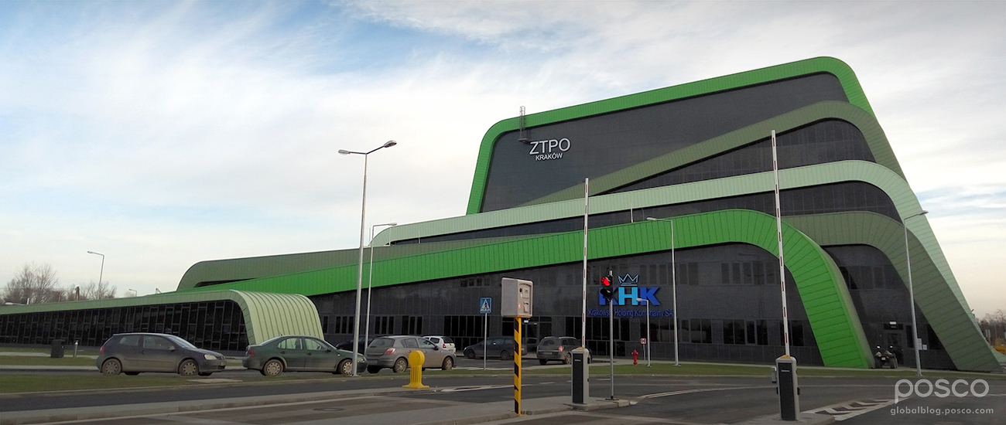

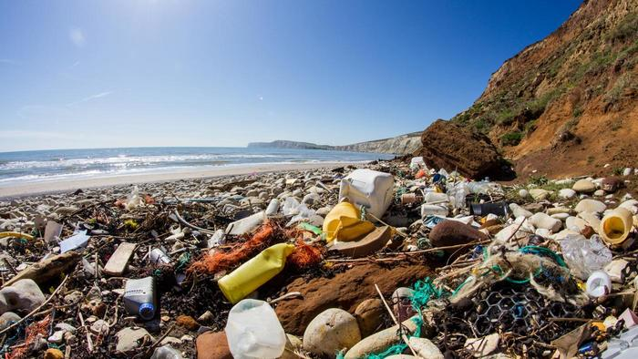

# 

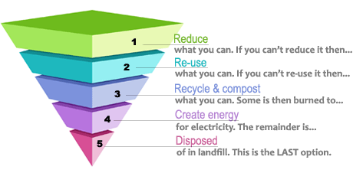

**WHAT WE HAVE TO OFFER**

TNL’s vision encourages our company to achieve great heights in the renewable energy sector. TNL executives work directly with government agents and their associated regulatory bodies to tackle the rigid, difficult and time-consuming tasks associated with **obtaining appropriate licenses, permits and inspections**, as well as any other “red-tape-driven” tasks. Among the values underpinning our success is:

• Dedicated to excellence by leveraging competitive advantages in technology and management.

• Adopting latest technology in the field of construction to execute projects with requisite detailing within the allotted time frame.

• Fair Trade, Strive for Quality and Respect for people’s hard work & commitment.

• "Quality is priority" with due adherence to environmental and legal requirements.

TNL provides comprehensive electrical engineering, civil engineering, structural engineering and value engineering services to all its clients.

**WHAT MAKES US UNIQUE**

TNL resolves to achieve and sustain a reputation for excellence and strives to satisfy the customer’s needs, by executing the works to consistently high quality standards at competitive prices and within the agreed upon timeframe.

We shall comply with the requirements and continually improve the quality management system with the following objectives:

• Enhanced customer satisfaction

• Employee motivation and empowerment.

• Continual growth with a vision to be leading global renewable energy company.

****

Micro Grid PV System Solar street light system

So

Solar pump power system

BAPV – Building Attached PV System

Large ground photovoltaic power plant

**Values**

The **TNL** vision encourages our company to achieve great heights. Among the values underpinning our success are:

* Characterized by **TRUST.** At the core of our professionalism is providing sense of security, credibility and confidence in our stakeholders when dealing with us.
* Action with **ACCOUNTABILITY.** We pride ourselves for taking full ownership of outcome of projects we execute for customers. That is why we put all our resources into ensuring that all projects are delivered with utmost professionalism.
* Grounded in **RESPECT.** We are not just about achieving our vision; we place a high premium on the feelings, wishes, ideas and rights of every stakeholder we come into contact with during this process.
* Essence of**ACCESSIBILITY.** Due to the criticality of the services, we provide, we are committed to being available 24/7 to our customers.
* Essence of **NURTURING.** We want to provide physical and emotional care and nourishment to our environment, while contributing to the future sustainability of the human specie
* At the forefront of **INNOVATION.** We want to partner with the best value adding organizations in the world to provide cutting edge technologies in delivering services to our customers and stakeholders.
* Grounded in**SOCIAL RESPONSIBILITY.** We will have zero tolerance at environmental degradation or any consequences that will adversely affect the communities we operate in.

# Health and Safety

The health and safety of TNL employees, consultants, partners, and clients supersedes all other TNL initiatives. We are dedicated to promoting a workplace that is as safe and possible through:

* Strict adherence to Occupational Safety & Health Administration (OSHA) are a key priority in terms of our SOPs.
* Implementing a safety strategy with a target of “ZERO” reportable accidents
* Enforcing a site-specific induction process before anyone is permitted to work at site.
* Holding workshops on health and safety practices and setting up a system to disseminate lessons learned.
* Endorsing “SAFETY FIRST” consciousness among all staff and workers
* Emergency Response Plans
* Periodic safety regular inspections at regular intervals
* Personal protection gear
* Expert training of employees

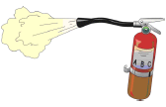 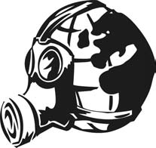

# Social Responsibility

Social responsibility is paramount for international organizations that focus on improving citizens’ quality of life through the delivery of stable and sustainable energy. The ambition of International Energy Development Group extends far beyond the boundaries of its business activities. We strongly believe in supporting projects that improve the lives of people in the local communities where we operate.

As such, TNL’s commitments to social responsibility include:

* Ensuring ecological conservation and development
* Abiding by health and safety standards
* Adhering to all quality, health, safety and environmental requirements, guidelines, and goals at project sites from design to completion
* Transforming society to be in harmony with the environment by making dedicated efforts to reduce our direct and indirect environmental impacts

# 

  

# Quality

TNL resolves to achieve and sustain a reputation for excellence in the domestic and international arena and strives to satisfy customers’ needs by executing to consistently high quality standards at competitive prices and within the agreed upon timeframe.

We shall comply with the requirements and continually improve the quality management system with the following objectives:

* Enhanced customer satisfaction
* Employee motivation and empowerment
* Continual growth with a vision to be the leading global renewable energy company

**Quality Objectives**

The following corporate quality objectives shall be planned and coordinated for effective implementation and follow up.

* Detailed planning of activities to ensure completion within specified timeframes
* Continuous review and control of costs to ensure completion of works within specified budget
* Achieving high client satisfaction in all activities
* Knowledge sharing through structured training programs

**Engineering**

Realizing that commercial and utility-scale energy development projects require in-depth, locale-specific engineering consideration prior to building development plans and budgets, **Taranis Novus Limited (TNL)** provides comprehensive civil engineering, structural engineering and value engineering services to all its clients.

With the outcome of energy development projects ultimately dependent upfront engineering, TNL works with leading engineers to ensure all bases are covered prior to making construction decisions. TNL engineering team members assist with:

* property analysis, including drainage, grading, geology, topography, hydrology, and weather pattern assessments.
* proximity assessments, including distance to roads, existing local transmission lines, and international power lines.
* surveys and mappings
* air quality and runoff studies
* exiting power grid capacity studies
* site plans
* facility architecture
* and more



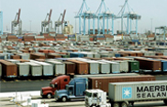



**Procurement**

#### Pre-Development Expertise

TNL executives work directly with government agents and their associated regulatory bodies to tackle the rigid, difficult, and time-consuming tasks associated with **obtaining appropriate licenses, permits, and inspections**, as well as any other “red-tape-driven” tasks.

To ensure that energy development projects kick-off smoothly, TNL will address:

* Pre-feasibility and Feasibility Analysis
* Deposits for obtaining site control of already identified locations via purchase and sale agreement or long-term land lease.
* Surveys, Plotting, and Civil Engineering
* Environmental Impact Studies
* Government Licensing Fees
* Permitting, Licensing, and Interconnection
* Legal and Professional Services
* Other Related Services with In-Country Agencies and Firms
* and more

**Construction**

With more than 25 years of large-scale construction experience, TNL team members are trustworthy resources who will pilot your energy development and infrastructure projects to successful completion.

In many cases, governments in need of stable energy are looking to move as quickly as possible. We at TNL are committed to meeting the needs of government clients and their citizens, but we place great value on safety, quality, and sound project management. TNL will work toward meeting project deliverables as quickly as possible, although our project managers will first work with clients to assess their needs and requirements and to set reasonable goals and timelines.

After engineering, procurement, and planning processes are complete, TNL construction teams will handle all aspects of the buildouts for our clients’ solar and/or thermal energy parks. TNL construction services include:

* Comprehensive project management
* On-site oversight
* Site clearing
* Facility build-out
* Utility connections
* Roadway construction
* Connections to power grid
* Ongoing management of government and third-party relations



# 

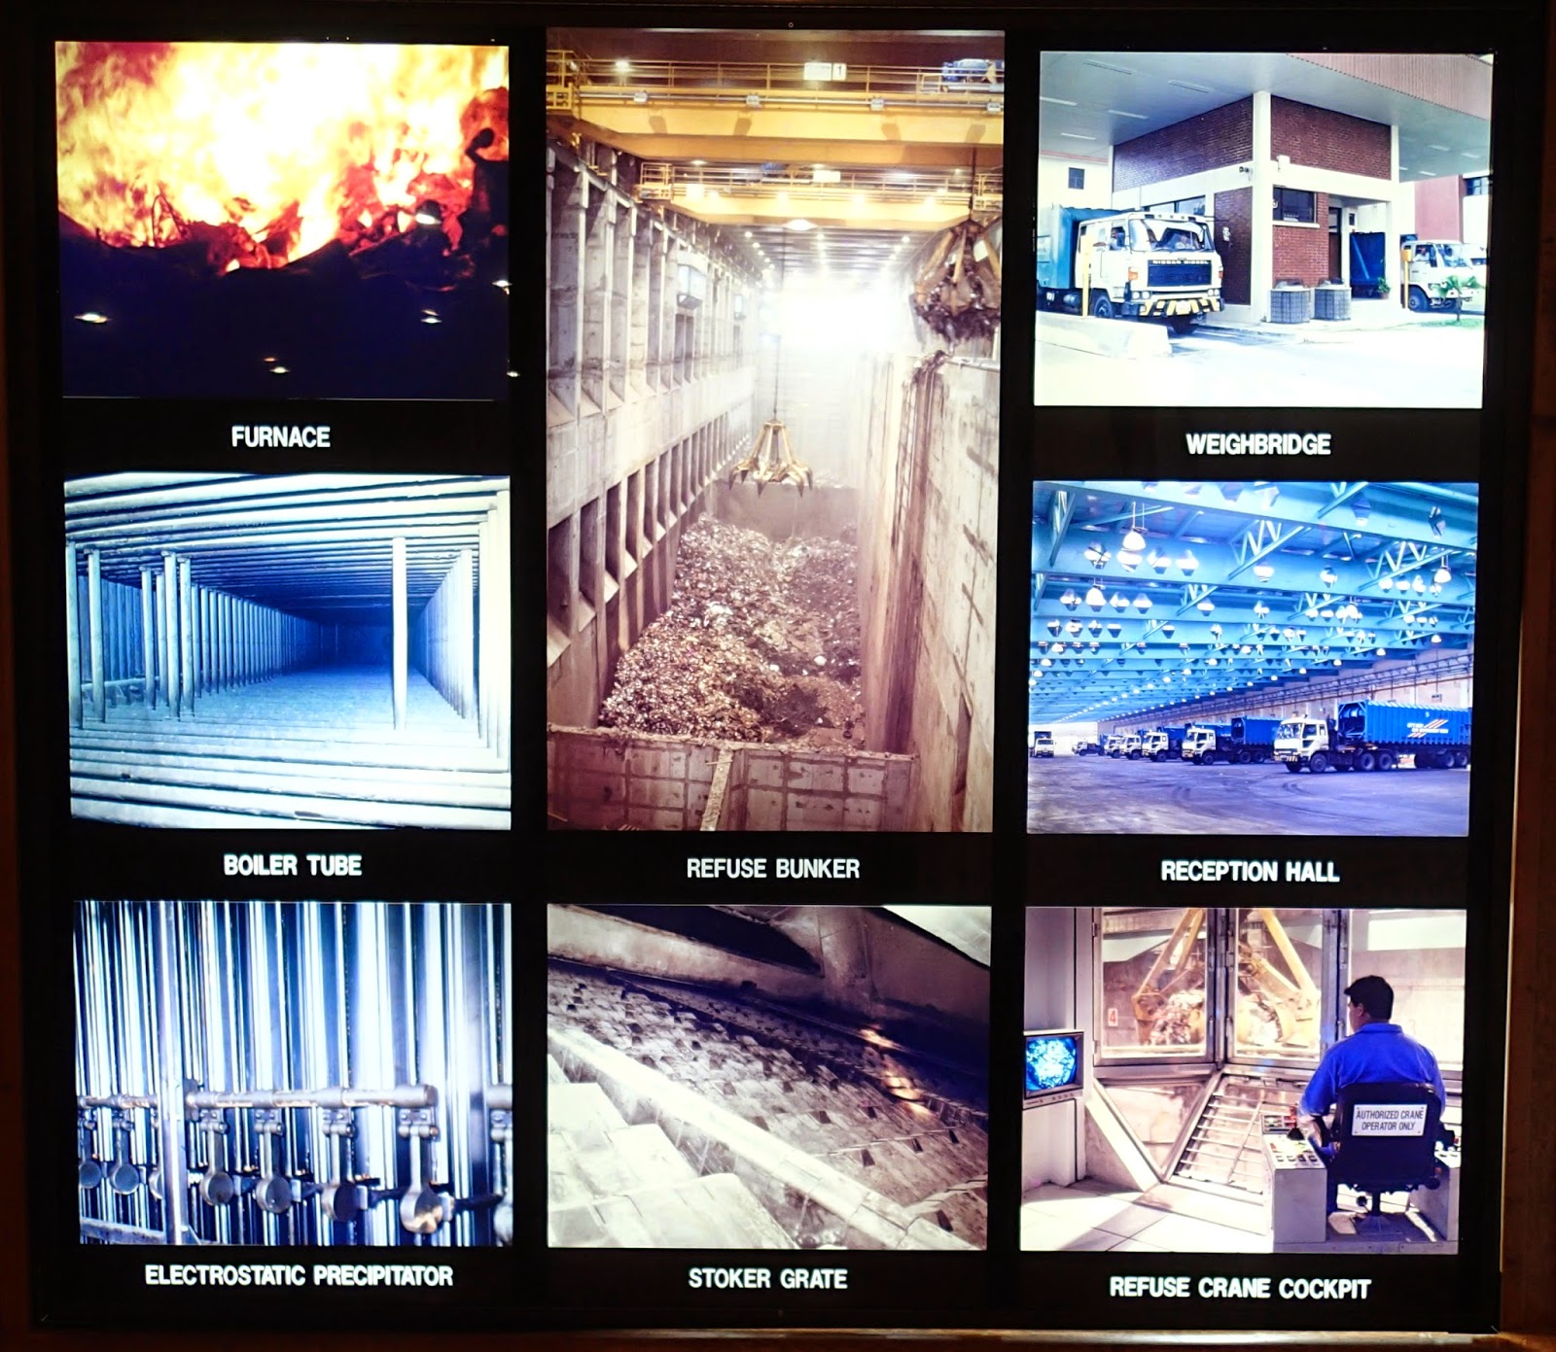

# 

**Operations**

Solar plant or natural gas plant operations require experience, skill, and labor. As such, International Energy Development Group will continue to work with clients after plant construction to ensure the plants are operating safely and at their full potentials.

TNL provides clients with:

* Plant commissioning
* Overall oversight of plant operations
* Plant recruiting and staffing services.
* Staff training (for all levels of plant operations personnel)
* Continuous monitoring and testing
* O & M Agreements and Plans



**Maintenance**

***Combined***

***Cycle***

***Engines***

# Solar Park Construction

 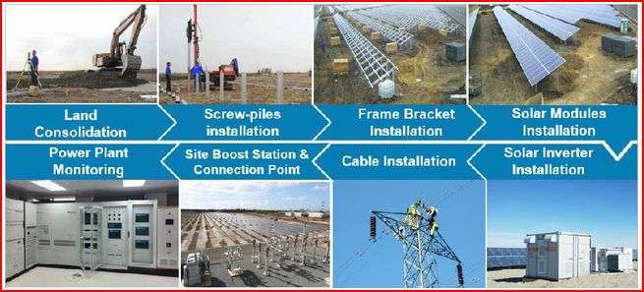

**Maintenance**

Proper maintenance to any energy park is paramount to ensure optimal production and efficiency. After plant commissioning, TNL will continue work with clients to provide a comprehensive list of maintenance services, including:

* Regular inspections
* Production output monitoring and adjusting
* Circuit Testing
* Calibration
* Performance Testing
* Facility and system corrective maintenance
* Solar Array Cleaning

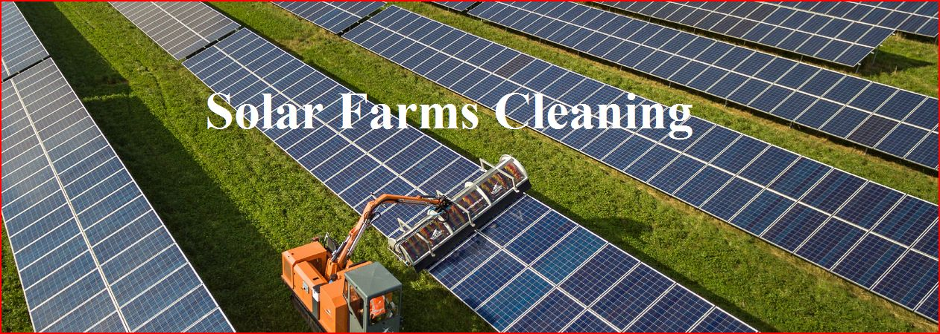



# 

# BENEFITS OF CHOOSING TNL FOR BUILDING ENERGY AND INFRASTRUCTURE PROJECTS.

* TNL is one of the foremost American business corporations, leader in the development and management of infrastructure, renewable energy and related services.
* TNL principals are made up of a team of seasoned engineering design and environmental management professionals, experienced chartered engineers, technologists and corporate professionals with more than 120 years of combined industry experience.
* TNL’s energy infrastructure offer covers the whole value chain, from design and construction to operation and maintenance.
* With its diversified global presence worldwide, the group develops its business activities based on the desire to contribute to economic and social development in the communities in which it operates.
* TNL executes its sustainability strategy through a sustainability master plan, a roadmap containing all the initiatives of the company in this field.
* The sustainability plan is structured by strategic and operative objectives applied across the organization, with specifications for the different areas of business with the aim of bringing sustainability closer to the particular nature of each line.
* The ultimate aim of TNL is to lead the transition towards a low-carbon economy, bringing quality criteria and innovation processes to all projects in order to optimize the efficient use of resources and respect the environment, with the ambition and determination to become a carbon-neutral company. Completely in sync with United Nation’s Sustainable Development Goals (SDGs)
* TNL’s technology capability to meet all contractual targets and requirements.
* TNL’s full-proof, tested, tried and proven capability of the state-of-the-art technology solution proffered.
* It’s EPC Company’s top reputation (CGGC) with wide experience & advanced engineering technology in numerous development sectors.
* The technical/engineering and financial credibility of TNL’s EPC partners.

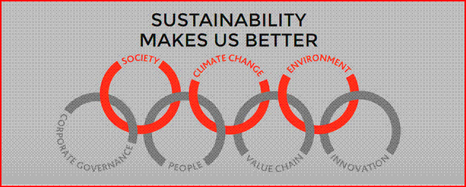

# TNL Model template for the Design and Construction of Energy / INTEGRATED Industrial Parks

This commitment is part of the driving force and strong emphasis TNL places on the development of Building Energy and Infrastructure Projects via the design and construction of Integrated Industrial Energy Parks.

Industrial parks can be instrumental in developing a country’s economy. Not only do they provide a venue to attract businesses, which in turn directly add to the economy, they are often designed to attract companies operating in a particular sector, which helps bolster a country’s reputation in that field. Hence the mandate to focus on the achievement of development of embedded power generation for the Industrial Park is primary and key for further development of the energy park.

Eco-Industrial parks strive to take full advantage of symbiotic industrial processes and provide and create numerous employment opportunities as well as economic benefits to the community and the environment.

A Water Treatment Plant will be housed within the industrial park to enable a meaningful presence for availability of potable water.

Industrial parks often offer purpose-built space and come with amenities, location incentives and a ready-to-go infrastructure that reduces the time it takes for a company to get up and run­ning. They are designed to make starting a business easy, but first, as with any location, they must attract investors. And with a growing number of industrial parks emerging the world over, this eventually stimulates developmental economic growth.

The TNL industrial energy park model is designed to comprise modern, modular industrial facilities, aimed at companies that do not want to build their own pro­duction facilities either due to time con­straints or finances. The industrial energy park, when fully designed and built, will cover an appreciable land space spanning about 30 – 50 hectares in land space. These purpose-built spaces will be designed and specifi­cally aimed at companies involved in scientific and pro­duction activity, such as electric Vehicles Assembly Plant, polymers pro­cessing, plastics manufacturing, com­puter chips assembly, pharmaceuti­cals production, cottage industries etc. to mention a few.

**Why TNL** ?

The primary reasons are based on

* Project Design, Origination & Delivery – We support project development, value improvement, procurement and contracting, project execution, and distressed project turnarounds.
* Portfolio Optimization -- Our innovative approach to sustaining capex consistently helps clients reduce their capital spend.
* Organization -- We design project organizations and owner’s teams, support capability building, and help implement management processes that enable project success while working with project owners; engineering, procurement and construction companies; and construction contractors.
* Final Assessments & Conclusion – We conduct structured assessments based on targeted analysis, interviews, and document reviews across the technical, execution, financial, political, and organizational aspects of a project pre conclusion.

# PICTORIAL IMPRESSION OF THE PROPOSED ENERGY / INTEGRATED INDUSTRIAL PARKS

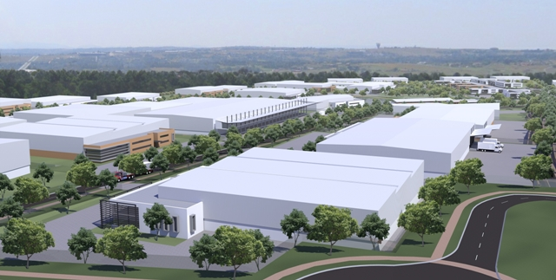

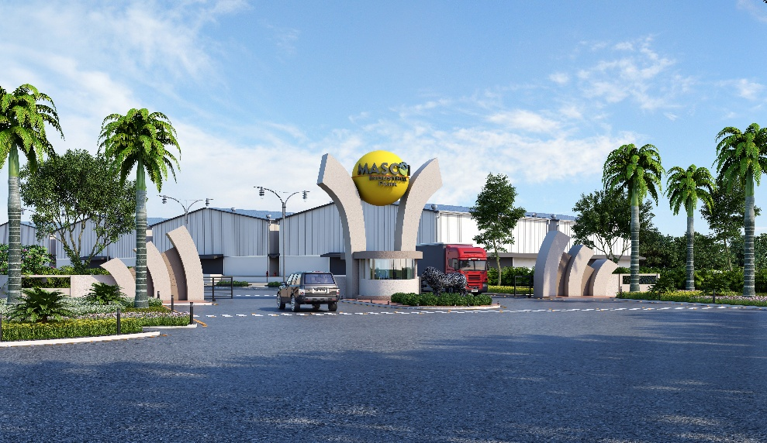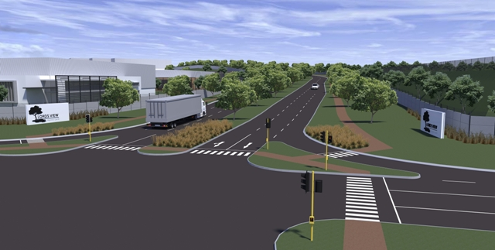

# TNL DEVELOPMENT TEAM

C:\Program Files\Common Files\Microsoft Shared\Clipart\cagcat50\bd06982_.wmf

**GLOBAL EXPERIENCE**

**Taranis Novus Limited (TNL)** – Solar, Wind, Waste to Energy, CSP, Geo-Thermal, Thermal & Hydro Energy Park Developer

**CGGC Consortium –** Renewable Energy Mix, World Class Engineering and Procurement of the Best Technology, State of the Art Construction and some of the Best Financial Partners to bring the Financing to the Energy Projects that we develop.

**LITHTECH (TBA)** – Industry State of the Art OEM/ Best Technology equipment specialist and turnkey solutions providers for innovative IOT-enabled machine control solutions and offering best product and business service offerings.

**OCFE (TBA)** – Electrical Vehicles Assembly Plant

* TNL executives have long-standing track records of developing solar energy and thermal energy plants, stations, parks, and facilities in Africa and Latin America.
* Committed to bringing electricity to those in need, which in turn has helped us gain much-valued respect with governments of countries and their respective leaders and citizens.
* Our focus on building relationships with government decision makers, regulatory bodies, raw materials suppliers, technology vendors, engineering firms, and downstream labor forces, sets us apart from our competitors.

**TEAM**

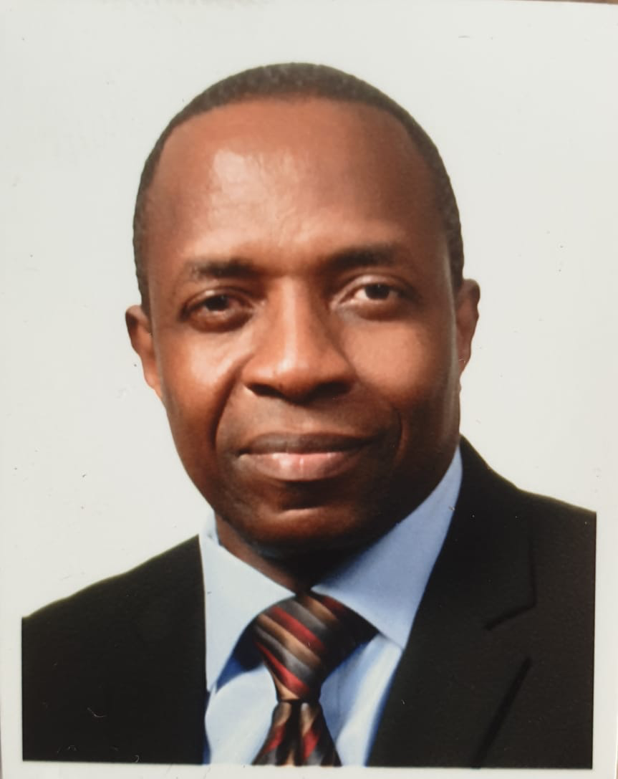

*Over 35 years of professional experience spanning a diversity of business segments, including Government, Electronic Banking and Financial Services, Oil and Gas, Telecoms, Medical Technology, Manufacturing and Construction industries.*

* Responsible for all TNL’s operation and market development in Nigeria
* Qualifications: B.Sc. Computer Sciences, Advanced certification in ATM-PAS programming (NCR Training Institute, Sheldon. Birmingham. UK). Enrolled at the University College Cardiff, Wales for a master's degree program in Operations Research. Chartered IT professional member of the British Computer Society as well as the Computer Professional Registration Council of Nigeria (CPN).
* Develop, originate, structure and negotiate opportunities across Nigeria and beyond, with a strong focus on physical power purchase agreements.
* Assess and prioritize energy markets, in working with our structuring team to evaluate projects and monitor key government regulatory drivers and market indicators to inform the business execution.
  + .

**Femi Numa**

**Co-founder Managing Director/CEO**

**Femi Numa**

**President IEDG Nigeria**

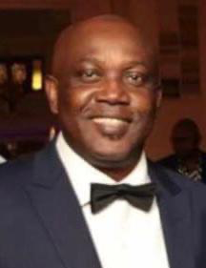

Over 27 years of professional experience spanning a diversity of business segments, including Aviation, Manufacturing, Financial institutions, Oil and Gas and IT Services Providers (i.e., Dell, IBM and Fujitsu Computer Services

• Qualification: A Pioneer Graduate of Lagos State University with Bachelor of Science degree in Mathematics and Bachelor of Science degree in Business information system from University of East London. An experienced Chartered IT Consultant, Certified Project Management Professional, an Agile Certified Practitioner, a Member of British Computer Society and a Member International Information System Security.

• Develop and implement a long-term commercial model to ensure the long-term financial sustainability of the TNL in Nigeria.

• Develop and maintain sector integrity and probity measures to ensure stakeholder confidence in the TNL commercial interests, particularly in relation to Business development growth

**‘Kenny Olaleye**

**CO-founder/Deputy Managing Director/DCEO**

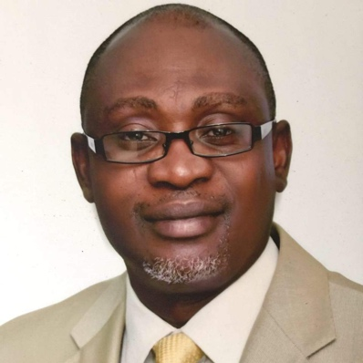

Bunmi is a transformational IT executive with over two decades leading change in business enterprise environments. His background spans Banking, Pharmaceuticals, Innovation, Governance and Leadership roles in Information Technology in many engagements in IBM business services, Sanofi Pharmaceuticals, XO communications, Executive Council; Ogun State Govt. of Nigeria, Citizen's bank N.A, Bank of America N.A and Infosys Technologies.

* Qualifications: B.Sc.International Relations University of Ife, Nig. (now OAU), Grad.Cert, New Media, University of Missouri-Columbia, MO United States, Certs. in Project-Mgmt, Rutgers University New Brunswick NJ, Certificates in Technology Entrepreneurship: Lab to Market, and Entrepreneurship in Emerging Economies, HarvardX of Harvard Business School, Cambridge MA.
* Responsible for all TNL’s business strategy implementations and day-to-day operations as Chief operating officer (COO)
* Enforcing and implementing company’s standards and carrying out the company’s business plans.
* Implementing and monitoring the operational functions of TNL, which includes administrative activities.

**‘Bunmi Adebayo**

**Co-founder/Chief Operating Officer**

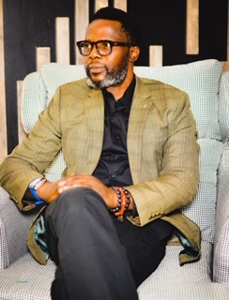

**Paul Ojeikere**

**Co-founder/Chief Information Officer & Strategist**

Paul Kunle Ojeikere (PKO) is a seasoned CIO, Corporate Strategist, and multi-certified Project/Program Manager with vast leadership experience spanning over three decades and cutting across various industries and cultures. Some of the organizations he played key roles in include Avery Group L.L.C, Trojan Technologies Inc. and The Searle company all in North America; CBN, Globacom and BAT in Nigeria.

* Qualifications: PKO is a PIONEER Alumnus of Lagos State University where he graduated with a B.Sc. (Hon’s.) degree in Political Science. He also has M.Sc in Information Systems Development at the London School of Economics. He's also served as Commissioned Officer with Canadian Reserved Forces 705 Comms Squadron. His certifications are PMP, PMI-ACP, TOGAF, SAFe 5.

His responsibilities as CIO/Strategist include:

* Formulation of strategies with alignment to corporate vision and mission; supporting the leadership direction and governance necessary to ensure the successful delivery.
* Designing and customizing corporate technological systems and platforms to improve customer experience.

**Gboyega Adepegba**

**Co-founder/Chief Technology Officer**

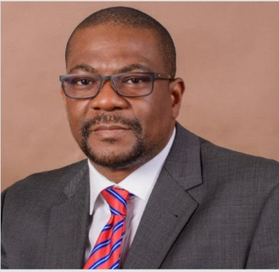

With over 30 years of extensive experience across the oil and gas industry value chains, Jimi worked across two producing companies, Shell Petroleum Development Company of Nigeria (SPDC) and Consolidated Oil Limited. His skill sets include Petroleum Engineering (Production Technologist/Engineering), Petroleum Economics (Commercial), Business Planning, Reserves Accounting, Project Management, Logistics and Procurement. He later retired in SDPC as the Economics Lead.

* Qualifications: Jimi Akande holds a B.Sc degree in land survey from the University of Lagos, a post graduate diploma in Energy Management from City University London, UK, a diploma in petroleum engineering from OGCI Training Inc, Houston, Texas, USA.

His responsibilities as CMO includes.

* Creating relationship between the company and the target market.
* Using Contacts to win Projects and Procurement of Products.
* Maintaining a good relationship with customers and build loyalty.
* Planning Strategy to boost company value brand vis-à-vis what competitors offer.

**Jimi Akande**

**Co-founder/Chief Marketing Officer**

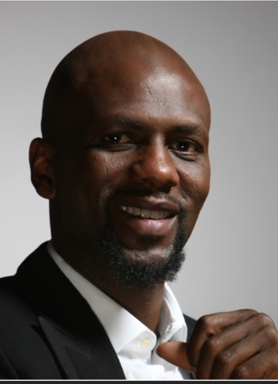

With Over 25 years’ experience in the film and marketing communications industry telling both brand and creative stories that sell. A well-known face and voice Infront and behind the camera. A Serial Entrepreneur. He started out as a copywriter in the global ad agency Leo Burnett Lagos. Fabian was the Founder of, Deo Media Holdings SA, Partner Blue Flamingo Africa, Co- Founder,Go- Digital Africa, Co – Founder;1 Take Media SA, Founder, Blu Jeans Communications, and Manager creative, Rosabel Leo Burnett Lagos.

* Qualifications: B.Sc Psychology University of Ibadan, member of ARCON (Advertising Regulatory Council of Nigeria).

As the Chief Communications and Strategy Officer of TNL, his roles includes:

* Serving as chief communication strategist and overseeing all functions responsible for planning and development of communications, marketing, media and public relations programs of TNL
* Using research and data-based decision making to provide comprehensive and strategic communications, news and marketing trend analysis, and recommendation.

**Fabian Adeoye Lojede**

**Co-founder/Chief Communication and Strategy Officer**



With over 30 years of extensive experience across the oil and gas industry value chains, Jimi worked across two producing companies, Shell Petroleum Development Company of Nigeria (SPDC) and Consolidated Oil Limited. His skill sets include Petroleum Engineering (Production Technologist/Engineering), Petroleum Economics (Commercial), Business Planning, Reserves Accounting, Project Management, Logistics and Procurement. He later retired in SDPC as the Economics Lead.

* Qualifications: Jimi Akande holds a B.Sc degree in land survey from the University of Lagos, a post graduate diploma in Energy Management from City University London, UK, a diploma in petroleum engineering from OGCI Training Inc, Houston, Texas, USA.

His responsibilities as CMO includes.

* Creating relationship between the company and the target market.
* Using Contacts to win Projects and Procurement of Products.
* Maintaining a good relationship with customers and build loyalty.
* Planning Strategy to boost company value brand vis-à-vis what competitors offer.

**Jimi Akande**

**Co-founder/Chief Marketing Officer**



With Over 25 years’ experience in the film and marketing communications industry telling both brand and creative stories that sell. A well-known face and voice Infront and behind the camera. A Serial Entrepreneur. He started out as a copywriter in the global ad agency Leo Burnett Lagos. Fabian was the Founder of, Deo Media Holdings SA, Partner Blue Flamingo Africa, Co- Founder,Go- Digital Africa, Co – Founder;1 Take Media SA, Founder, Blu Jeans Communications, and Manager creative, Rosabel Leo Burnett Lagos.

* Qualifications: B.Sc Psychology University of Ibadan, member of ARCON (Advertising Regulatory Council of Nigeria).

As the Chief Communications and Strategy Officer of TNL, his roles includes:

* Serving as chief communication strategist and overseeing all functions responsible for planning and development of communications, marketing, media and public relations programs of TNL
* Using research and data-based decision making to provide comprehensive and strategic communications, news and marketing trend analysis, and recommendation.

**Fabian Adeoye Lojede**

**Co-founder/Chief Communication and Strategy Officer**

**INTERNATIONAL EXPERIENCE / TNL’s TECHNICAL PARTNERS**



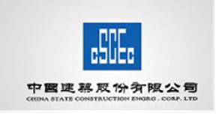

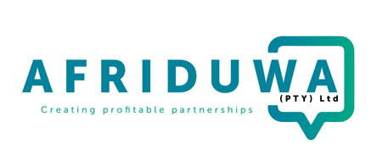

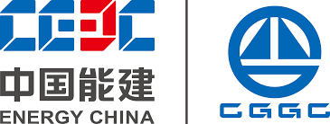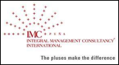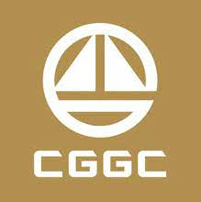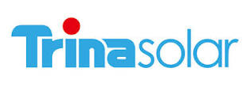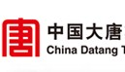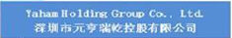 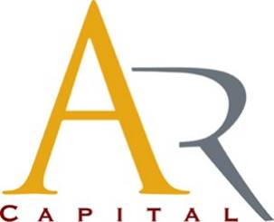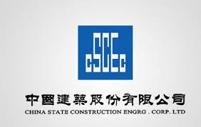

**CONTACT INFO**

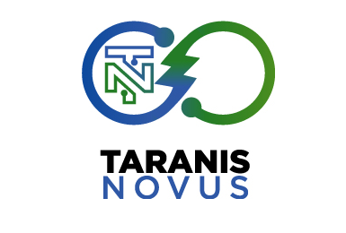

**Registered Office: 19A, Amore Street, Off Toyin Street, Ikeja, Lagos, Nigeria  
Website: www.tnlafrica.com.com**

**Email:** info@tnlafrica.com.com  
**Tel: +234 808 576 6753    +234 809 944 4124**

**Mobile U.S.A.:** +1.610.389.8642

**Mobile Ghana:** +233.504.555.400

**Office U.S.A.:**   +1.844.432.6854 Ext. 101

**Skype:**    James.Brown9499  
**Web:**     www.IEDGinc.com

**Email:**    JBrown@IEDGinc.com

# Disclaimer

**Disclaimer** *All Rights Reserved TNL © 2023*

*This document is private and confidential and you may not distribute it in whole or part to any third parties without our express written permission. It is for your information only and is not intended for publication elsewhere.*

*It has been prepared solely for informational purposes and does not constitute advice. It is neither an offer, recommendation nor a solicitation to buy or sell any investment, nor is it an official confirmation. It is prepared from information believed to be reliable, but we do not guarantee the accuracy of the information, which may be incomplete or condensed.*

*Any price or yield information is indicative only and subject to change without notice, and should not be used as a basis or any decision. IEDG accepts no liability for any direct, consequential or other loss or damage occurring from the use of this information only and is not intended for publication elsewhere.*